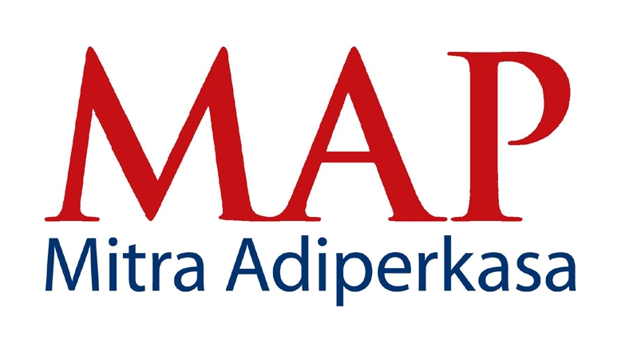
PRESS RELEASE
For Immediate Release

MAP ANNOUNCES 26% SURGE IN NET REVENUE FOR FIRST QUARTER 2014

Jakarta, 30th April 2014 – Indonesia’s leading lifestyle retailer, PT Mitra Adiperkasa Tbk (MAP) today announced its financial result for first quarter ended 31st March 2014. Net revenue jumped 26% to a record Rp 2,675 billion – up from the Rp 2,118 billion achieved in the first quarter of 2013. Gross profit grew 20% from Rp 1,034 billion to Rp 1,245 billion. Operating profit was
Rp 122 billion while net profit was Rp 46 billion.

Commenting on the result, Corporate Secretary of MAP, Fetty Kwartati said, “We have delivered good top line growth in a very challenging business environment. Rising operational cost and fluctuating rupiah have dampened our performance. Notwithstanding these challenges, we remained focus in our strategy to deliver long term growth. Going forward, we will continue to watch our costs carefully and strive to further improve operational efficiency and productivity.”

About PT Mitra Adiperkasa Tbk
As of March 2014, MAP operates 1,809 retail outlets in 59 major cities throughout Indonesia. The major retail concepts under the group among others: Department Stores: Sogo, Debenhams, Seibu and Galleries Lafayette; Fashion & Lifestyle: Zara, Marks & Spencer, Topman, Topshop, Next, Kipling, Lacoste, Nautica, Massimo Dutti, Staccato, DKNY, Crabtree & Evelyn, Swarovski and Zara Home; Sports: Converse, Golf House, Payless ShoeSource, Oakley, Planet Sports, Reebok, Rockport, Skechers, Sports Station, The Athlete's Foot and The Sports Warehouse; Food & Beverage: Starbucks, Burger King, Domino’s Pizza, Pizza Marzano, Krispy Kreme, Cold Stone Creamery Ice Cream, Godiva and Chatterbox; Kids: Kidz Station, Oshkosh B’Gosh, Barbie Boutique and Stride Rite; Others: Kinokuniya and Alun Alun. For more information about MAP please visit www.map-indonesia.com

For more information, please contact:
Fetty Kwartati
Corporate Secretary
PT Mitra Adiperkasa Tbk
Wisma 46, 8th fl. - Kota BNI
Jl. Jend. Sudirman Kav. 1
Jakarta 10220

Phone : 021 575 0755
Fax : 021 574 0150
Email : fetty.kwartati@map.co.id



SIARAN PERS
Untuk Didistribusikan Segera

PENDAPATAN BERSIH MAP MENINGKAT 26%
PADA KUARTAL PERTAMA TAHUN 2014

Jakarta, 30 April 2014 – PT Mitra Adiperkasa Tbk (MAP), perusahaan ritel gaya hidup terkemuka di Indonesia hari ini mengumumkan pencapaian pendapatan untuk kuartal pertama yang berakhir pada 31 Maret 2014 . Pendapatan bersih meningkat 26% menjadi sebesar
Rp 2.675 milyar – naik dari Rp 2.118 milyar yang tercatat di kuartal pertama tahun 2013. Laba kotor meningkat sebesar 20% dari Rp 1.034 milyar menjadi Rp 1.245 milyar. Sementara laba usaha tercatat sebesar Rp 122 milyar, dan laba bersih tercatat Rp 46 milyar.

Menanggapi kinerja keuangan kuartal pertama di tahun 2014, Fetty Kwartati, Corporate Secretary MAP menyampaikan, “Perusahaan telah mencapai pertumbuhan pendapatan yang baik di tengah kondisi usaha yang sangat menantang. Meningkatnya biaya operasi, nilai mata uang Rupiah yang fluktuatif telah memberikan pengaruh negatif pada kinerja kami. Namun terlepas dari semua tantangan tersebut, kami tetap fokus pada strategi kami untuk mencapai pertumbuhan jangka panjang. Melangkah ke depan, kami akan terus memantau biaya dengan hati-hati dan berusaha untuk terus meningkatkan efisiensi operasional dan produktivitas.”

Tentang PT. Mitra Adiperkasa Tbk
Per Maret 2014, MAP mengoperasikan 1.809 gerai ritel di 59 kota di Indonesia. Konsep utama yang dikelola oleh perusahaan diantaranya: Department Stores: Sogo, Debenhams, Seibu dan Galleries Lafayette; Fashion & Lifestyle: Zara, Marks & Spencer, Topman, Topshop, Next, Kipling, Lacoste, Nautica, Massimo Dutti, Staccato, DKNY, Crabtree & Evelyn, Swarovski dan Zara Home; Sports: Converse, Golf House, Payless ShoeSource, Oakley, Planet Sports, Reebok, Rockport, Skechers, Sports Station, The Athlete's Foot danThe Sports Warehouse; Food & Beverage: Starbucks, Burger King, Domino’s Pizza, Pizza Marzano, Krispy Kreme, Cold Stone Creamery Ice Cream, Godiva dan Chatterbox; Kids: Kidz Station, Oshkosh B’Gosh, Barbie Boutique and Stride Rite; Others: Kinokuniya dan Alun Alun. Untuk informasi lebih lengkap tentang MAP, kunjungi www.map-indonesia.com.

Untuk informasi lebih lengkap, mohon hubungi:

Fetty Kwartati
Corporate Secretary PT Mitra Adiperkasa Tbk
Wisma 46, 8th fl. - Kota BNI
Jl. Jend. Sudirman Kav. 1
Jakarta 10220

Telepon : 021 575 0755
Fax : 021 574 0150
Email : fetty.kwartati@map.co.id

