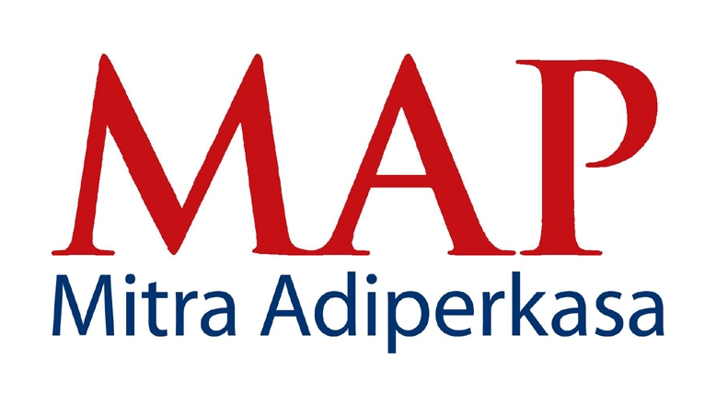

PRESS RELEASE
For Immediate Distribution

MAP Wins 3 Prestigious ASIA MONEY's Best Corporate Governance Awards

Jakarta, 31st January 2013 - Indonesia's leading retailer, PT Mitra Adiperkasa Tbk (MAP) was honored with 3 distinguished awards in AsiaMoney's 2012 Corporate Governance Poll:
(1) Best for Investor Relations (2nd Position)
(2) Best for Corporate Governance (3rd Position)
(3) Best for Shareholders' Right and Equitable Treatment (3rd Position)

Commenting on the awards, Fetty Kwartati, Corporate Secretary of MAP said: "MAP is indeed very honored to be given these awards. They are a testament to MAP's relentless efforts to uphold the highest standards of corporate governance and transparency."

Conducted annually by AsiaMoney to pick companies with the best corporate governance practices, winners were selected via a poll among CEOs, CIOs and senior executives from fund management and hedge fund companies in the Asia-Pacific region, as well as Heads of Research and senior analysts in brokerages across the region.

Criteria used to select winners include disclosure and transparency, efforts to promote and protect shareholders' rights, fair treatment of shareholders as well as initiatives to improve investor relations.

Throughout 2012, MAP held regular meetings and conference calls with analysts and investors and participated actively in conferences and NDRs (non-deal shows) organized by local, regional and global securities houses in Indonesia and overseas. In total, MAP received widespread coverage from more than 15 securities houses with regular update throughout the year. For its strong financial conditions, prospect of growth and high transaction value and frequency, MAP was chosen as one of the constituent stocks of the Indonesia Stock Exchange 's LQ 45 Index for the period February to July 2013.

A multi-award company, MAP was listed in Fortune Magazine's "Most Admired Companies" in 2012 and Forbes Magazine's "Top 40 Companies" in 2011. Currently, the Company has a total of 1,383 outlets in 48 cities - including brand icons like SOGO, Starbucks, Zara, Marks & Spencer, Reebok, among many others.

ABOUT PT MITRA ADIPERKASA TBK

As per December 2012, MAP operates 1,383 retail outlets in 48 cities of Indonesia. Major retail concepts under the group include:
- Department Stores: Sogo, Debenhams, and Seibu
- Fashion & Lifestyle: Zara, Marks & Spencer, Topman, Topshop, Next, Kipling, Lacoste, Nautica, Massimo Dutti, Pull&Bear, Dorothy Perkins, Miss Selfridge, Nine West, Stradivarius, Bershka, Samsonite, Linea, Steve Madden, Swatch, Loewe, BCBGMaxazria, MaxMara, Max&Co, Travelogue, Tumi, Sole Effect, Warehouse, H.E. by Mango, New Look, Staccato, Diva, DKNY, Crabtree & Evelyn, Desigual and Brook Brothers.
- Sports: Converse, Golf House, Payless ShoeSource, Planet Sports, Reebok, Rockport, Skechers, Sports Station, The Athlete's Foot and The Sports Warehouse.
- Food & Beverage: Starbucks, Burger King, Domino’s Pizza, Pizza Marzano, Krispy Kreme, Cold Stone Creamery Ice Cream, and Chatterbox.
- Kids: Kidz Station, Oshkosh B’Gosh and Barbie Boutique,
- Others: Kinokuniya and Alun Alun.

Apart from retailing, the group is also the leading distributor of over 90 international brands including Airwalk, Batman, Converse, Diadora, Lotto, Reebok, Speedo, Superman, Thomas & Friends, and many more. For more information about MAP please visit www.map-indonesia.com

For more information, please contact:

Fetty Kwartati
Corporate Secretary
PT Mitra Adiperkasa Tbk
Wisma 46, 8th fl. - Kota BNI
Jl. Jend. Sudirman Kav. 1
Jakarta 10220

Phone : 021 575 0755
Fax : 021 574 0150
Email : fetty.kwartati@map.co.id

SIARAN PERS
Untuk Didistribusikan Segera

MAP Raih 3 Penghargaan Bergengsi untuk Tata Kelola Perusahaan Terbaik dari
AsiaMoney

Jakarta, 31 Januari 2013 – perusahaan ritel terkemuka di Indonesia, PT Mitra Adiperkasa Tbk (MAP) dinobatkan meraih tiga penghargaan bergengsi dalam ajang AsiaMoney's 2012 Corporate Governance Poll:
(1) Best for Investor Relations (Posisi ke-2)
(2) Best for Corporate Governance (Posisi ke-3)
(3) Best for Shareholders' Right and Equitable Treatment (Posisi ke-3)

Mengomentari penghargaan yang diterima, Fetty Kwartati, Corporate Secretary MAP menuturkan, "Merupakan suatu kehormatan bagi MAP menerima penghargaan ini. Pencapaian ini menjadi bukti atas berbagai upaya perusahaan yang menerapkan standar tertinggi dalam tata kelola perusahaan dan keterbukaan informasi.”

Pemberiaan penghargaan AsiaMoney diselenggarakan setiap tahun untuk memilih perusahaan-perusahaan dengan praktek tata kelola perusahaan terbaik. Peraih penghargaan ditentukan melalui jajak pendapat yang melibatkan partisipasi para CEO, CIO dan eksekutif senior dari sejumlah perusahaan fund management dan hedge fund di wilayah Asia-Pasifik, serta kepala riset dan analis senior di perusahaan sekuritas di tingkat regional.

Kriteria yang digunakan untuk menentukan pemenang mencakup pernyataan dan keterbukaan informasi, upaya-upaya untuk mempromosikan dan melindungi hak-hak para pemegang saham, perlakuan yang fair terhadap para pemegang saham serta berbagai inisiatif untuk meningkatkan hubungan investor.

Sepanjang tahun 2012, MAP menggelar pertemuan-pertemuan rutin dan melakukan conference call dengan para analis dan investor, serta aktif berpartisipasi dalam konferensi-konferensi dan NDRs (non-deal shows) yang diselenggarakan oleh perusahaan-perusahaan sekuritas lokal, regional dan global, baik di Indonesia maupun di luar negeri. Secara keseluruhan, lebih dari 15 perusahaan sekuritas membuat report analisa perusahaan dan perkembangan analisanya disampaikan secara periodik. Atas kinerja keuangan perusahaan yang kuat, prospek pertumbuhan dan nilai transaksi serta frekuensi transaksi saham yang tinggi, MAP juga terpilih sebagai salah satu saham konstituen Index LQ 45 oleh Bursa Efek Indonesia untuk periode Februari hingga Juli 2013.

Sebagai perusahaan yang sering memperoleh penghargaan atas berbagai prestasinya, MAP sebelumnya telah meraih penghargan dari Majalah Fortune sebagai “Most Admired Companies” pada 2012 dan Majalah Forbes sebagai “Top 40 Companies” pada 2011.

Tentang PT. Mitra Adiperkasa Tbk
Per Desember 2012, MAP menjalankan 1.383 gerai ritel di 48 kota di Indonesia. Konsep utama yang dikelola oleh perusahan mencakup:

- Department Store: Sogo, Debenhams, dan Seibu
- Fashion & Lifestyle: Zara, Marks & Spencer, Topman, Topshop, Next, Kipling, Lacoste, Nautica, Mossimo Dutti, Pull & Bear, Dorothy Perkins, Miss Selfridge, Nine West, Stradivarius, Bershka, Samsonite, Linea, Steve Madden, Swatch, Loewe, BCBGMAXAZRIA, MaxMara, Max & Co, Travelogue, Tumi, Sole Effect, Warehouse, H.E by Mango, New Look, Staccato, Diva, DKNY, Crabtree & Evelyn, Desigual dan Brook Brothers.
- Sports: Converse, Golf House, Payless Shoe Source, Planet Sports, Reebok, Rockport, Skechers, Sports Station, The Athlete’s Foot dan The Sports Warehouse.
- F&B: Starbucks, Burger King, Domino Pizza, Pizza Marzano, Krispy Kreme, Cold Stone Creamery Ice Cream, dan Chatterbox.
- Kids: Kidz Station, Oshkosh B'Gosh dan Barbie Boutique
- Lain-lain: Kinokuniya dan Alun Alun.

Selain dari usaha ritel, grup MAP juga merupakan distributor terkemuka lebih dari 90 merek internasional termasuk Airwalk, Batman, Converse, Diadora, Lotto, Reebok, Speedo, Superman, Thomas & Friends, dan lain-lain. Untuk informasi lebih lanjut tentang MAP silakan kunjungi www.map-indonesia.com.

Untuk informasi lebih lanjut, hubungi:

Fetty Kwartati
Corporate Secretary
PT Mitra Adiperkasa Tbk
Wisma 46, 8th fl. - Kota BNI
Jl. Jend. Sudirman Kav. 1
Jakarta 10220

Telepon : 021 575 0755
Fax : 021 574 0150
Email : fetty.kwartati@map.co.id

