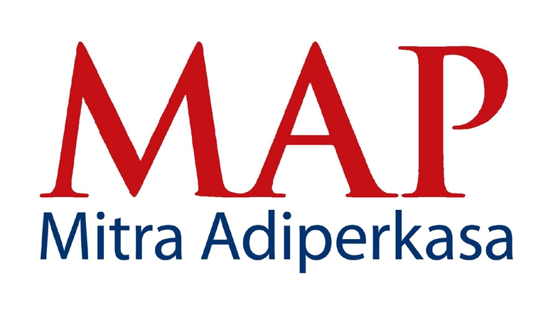

PEFINDO UPGRADES RATINGS OF MAP,
ITS BOND AND SUKUK TO "idAA-" and "idAA-(sy)"

Jakarta, 28th September 2012 - Pefindo has today upgraded its rating on PT Mitra Adiperkasa Tbk (MAP) and MAP's Bond 1/2009 (A&B series) from "idA+" to "idAA-". Pefindo also upgraded the rating of MAP's Sukuk Ijarah 1/2009 (A&B series) from "idA+(sy)" to "idAA-(sy)".

The upgrade is supported by MAP's steady business growth driven by sales growth of existing stores and successful store expansions, while maintaining strong cash flow protection ratios. MAP’s revenue grew by 25% year on year in 2011 and 30% year on year in first semester 2012. In 2012, MAP’s revenue is expected to increase by more than 20%, supported by around 300 new store openings.

The ratings reflect MAP's strong market position in the modern retail industry supported by its well diversified portfolio of 75 retail concepts, strategic alliance with over 100 of the world's best brands (including Sogo and Debenhams Department Stores, Reebok, Converse, Zara, Marks & Spencer, Starbucks among others), solid management team, its prime store locations and strong cash flow protection.

MAP also plans to issue new bonds amounting to Rp 500 billion which will be utilized to refinance its current bonds and working capital requirement. The new bonds are expected to be issued in December 2012.

With a current total of 1,209 stores in 42 cities, MAP is the leading lifestyle retailer in Indonesia with focus on the middle to upper consumer segments and with its diversified brands, MAP usually become the anchor tenant in major malls.

ABOUT PT MITRA ADIPERKASA TBK

As per August 2012, MAP operates 1.209 retail outlets in 42 cities of Indonesia. Major retail concepts under the group include:
- Department Stores: Sogo, Debenhams, and Seibu
- Fashion & Lifestyle: Zara, Marks & Spencer, Topman, Topshop, Next, Kipling, Lacoste, Nautica, Massimo Dutti, Pull&Bear, Dorothy Perkins, Miss Selfridge, Nine West, Stradivarius, Bershka, Samsonite, Linea, Steve Madden, Swatch, Loewe, BCBGMaxazria, MaxMara, Max&Co, Travelogue, Tumi, Sole Effect, Warehouse, H.E. by Mango, New Look, Staccato, Diva, Crabtree & Evelyn, DKNY and Desigual.
- Sports: Converse, Golf House, Payless ShoeSource, Planet Sports, Reebok, Rockport, Skechers, Sports Station, The Athlete's Foot and The Sports Warehouse.
- Food & Beverage: Starbucks, Burger King, Domino’s Pizza, Pizza Marzano, Krispy Kreme, Cold Stone Creamery Ice Cream, and Chatterbox.
- Kids: Kidz Station, Oshkosh B’Gosh and Barbie Boutique,
- Others: Kinokuniya and Alun Alun.

Apart from retailing, the group is also the leading distributor of over 90 international brands including Airwalk, Batman, Converse, Diadora, Lotto, Reebok, Speedo, Superman, Thomas & Friends, and many more. For more information about MAP please visit www.map-indonesia.com

For more information and hi res photos, please contact:

Fetty Kwartati
Corporate Secretary
PT Mitra Adiperkasa Tbk
Wisma 46, 8th fl. - Kota BNI
Jl. Jend. Sudirman Kav. 1
Jakarta 10220

Phone : 021 575 0755
Fax : 021 574 0150
Email : fetty.kwartati@map.co.id

PEFINDO NAIKKAN PERINGKAT MAP,
OBLIGASI DAN SUKUK NYA MENJADI "idAA-" DAN "idAA-(sy)"

Jakarta, 28 September 2012 – PT Pemeringkat Efek Indonesia (Pefindo) menaikkan peringkat
PT Mitra Adiperkasa Tbk (MAP) dan Obligasi Mitra Adiperkasa I Tahun 2009 (Seri A&B) yang diterbitkan dari "idA+" menjadi "idAA-". Pefindo turut menaikkan peringkat Sukuk Ijarah Mitra Adiperkasa I Tahun 2009 dari "idA+(sy)" menjadi "idAA-(sy)".

Kenaikan ini dicapai berkat pertumbuhan bisnis MAP yang stabil, yang didorong oleh pertumbuhan penjualan gerai yang ada dan keberhasilan ekspansi gerai, serta tetap mempertahankan rasio proteksi arus kas yang kuat. Pendapatan MAP tumbuh 25% untuk tahun 2011 dan tumbuh 30% untuk periode semester pertama 2012. Perusahaan menargetkan pertumbuhan pendapatan lebih dari 20% tahun, dengan dukungan pembukaan 300 gerai baru.

Peringkat terbaru yang diraih perusahaan mencerminkan posisi pasar MAP yang kuat dalam industri ritel modern yang ditunjang melalui portofolio atas 75 konsep ritel, aliansi strategis dengan lebih dari 100 merek terbaik kelas dunia (diantaranya Sogo dan Debenhams Department Store, Reebok, Converse, Zara, Marks & Spencer dan Starbucks), tim manajemen yang kuat, lokasi-lokasi gerainya yang strategis serta kuatnya perlindungan arus kas.

MAP berencana untuk menerbitkan obligasi baru sejumlah Rp 500 milyar yang akan dimanfaatkan untuk pembiayaan ulang obligasi yang tengah berjalan dan memenuhi kebutuhan modal kerja. Obligasi baru ini diperkirakan akan terbit pada Desember 2012.

Dengan jumlah gerai sebanyak 1.209 di 42 kota, MAP merupakan perusahaan ritel terkemuka di Indonesia dengan pangsa pasar kelas menengah atas. Melalui keragaman merek-merek yang dikelolanya MAP menjadi penyewa utama di sejumlah mal berkelas.

Tentang PT MITRA ADIPERKASA TBK

Per Agustus 2012, PT Mitra Adiperkasa Tbk (MAP) mengoperasikan total 1.209 gerai ritel di 42 kota di Indonesia. Konsep ritel utama yang dikelola oleh perusahan mencakup:

- Department Stores: Sogo, Debenhams, dan Seibu
- Fashion & Lifestyle: Zara, Marks & Spencer, Topman, Topshop, Next, Kipling, Lacoste, Nautica, Massimo Dutti, Pull&Bear, Dorothy Perkins, Miss Selfridge, Nine West, Stradivarius, Bershka, Samsonite, Linea, Steve Madden, Swatch, Loewe, BCBGMaxazria, MaxMara, Max&Co, Travelogue, Tumi, Sole Effect, Warehouse, H.E. by Mango, New Look, Hoss Intropia, Staccato, Diva, Hoss Intropia, DKNY, Crabtree & Evelyn dan Desigual.
- Sports: Converse, Golf House, Payless ShoeSource, Planet Sports, Reebok, Rockport, Skechers, Sports Station, The Athlete's Foot dan The Sports Warehouse.
- Food & Beverage: Starbucks, Burger King, Domino’s Pizza, Pizza Marzano, Krispy Kreme, Cold Stone Creamery Ice Cream, dan Chatterbox.
- Kids: Kidz Station, Oshkosh B’Gosh, Stride Rite dan Barbie Boutique
- Others: Kinokuniya dan Alun Alun
Selain usaha retail, MAP juga merupakan distributor terkemuka untuk lebih dari 90 merek internasional, seperti Reebok, Speedo, Converse, Diadora, Lotto, Airwalk, Superman, Batman, OshKosh B'Gosh dan Thomas & Friends. Untuk informasi lebih lanjut mengenai MAP, silakan kunjungi www.map-indonesia.com

Untuk informasi lebih lanjut, silakan hubungi:

Fetty Kwartati
Corporate Secretary
PT Mitra Adiperkasa Tbk
Wisma 46, 8th fl. - Kota BNI
Jl. Jend. Sudirman Kav. 1
Jakarta 10220

Telepon: 021 575 0755
Fax : 021 574 0150
Email : fetty.kwartati@map.co.id

